GRADUATION DAY FOR THE BATCH 2019-2021

The Oxford College of Arts have organised the Graduation Ceremony to the Out Going MSW Batch of 2020-21 of the Department of Social Work on 18th September 2021. Mr Prathap JJ, The Legal Advisor and Coordinator, Souharda Family Counseling Centre, Bangalore, The Guest of Honour of the Ceremony addressed the students and threw light on paving the best way for bright future. Mrs. Ujwala Raju, Management Representative of the Oxford Institutions wished the career best opportunities to the outgoing students. The Department of Social Work accoladed the students with Best Outgoing Student Overall and Best Performer Awards in each Specialisation.

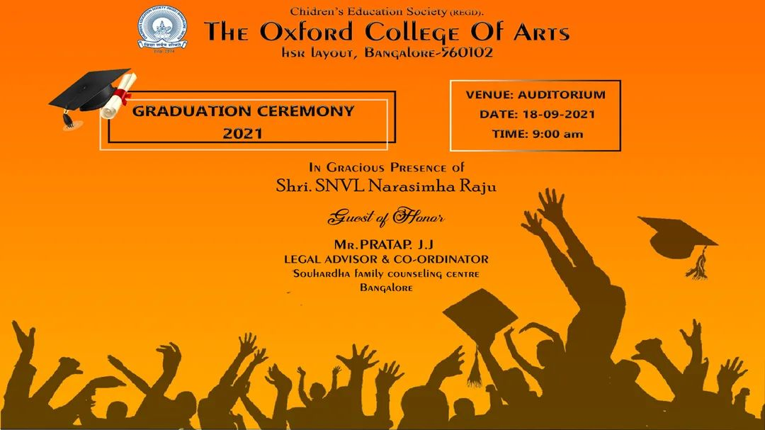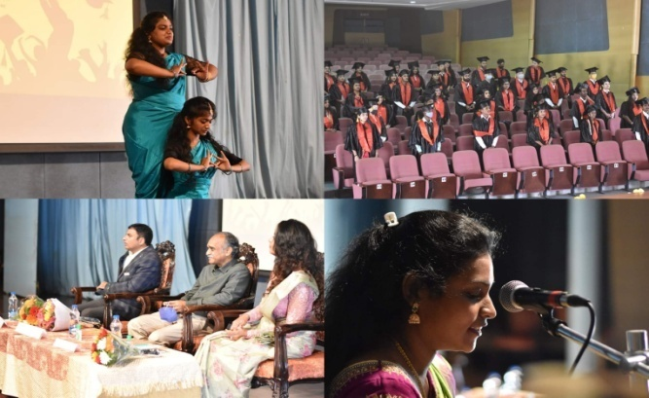
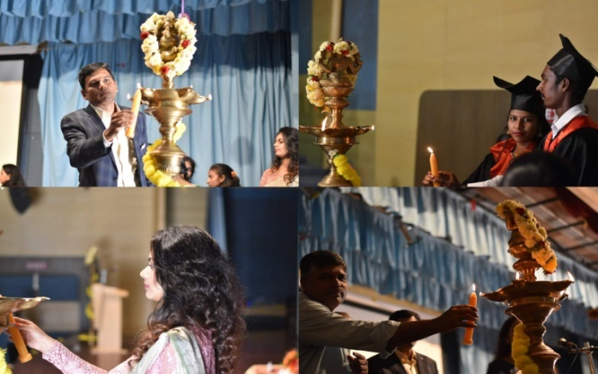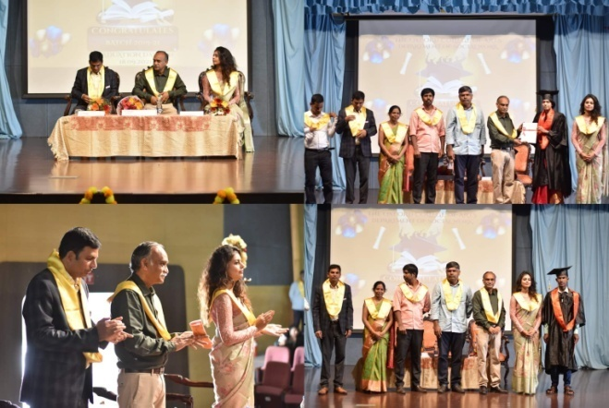
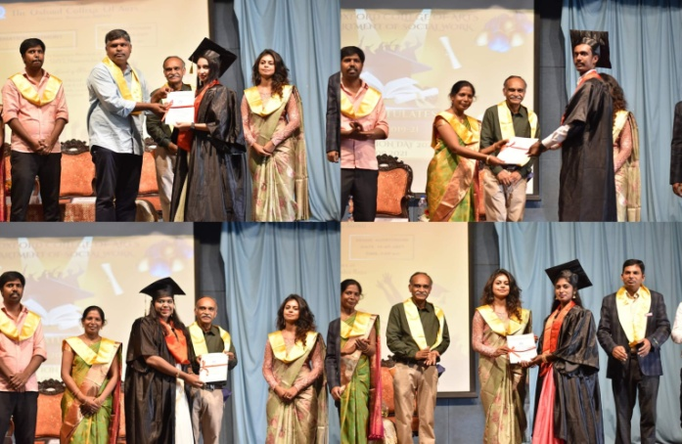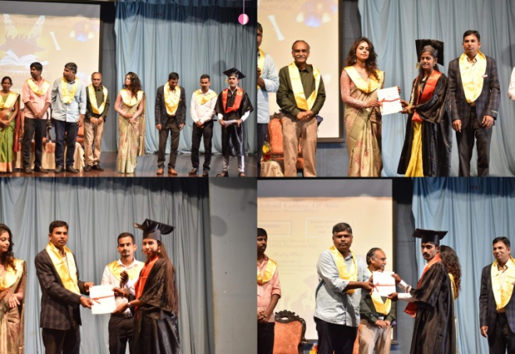
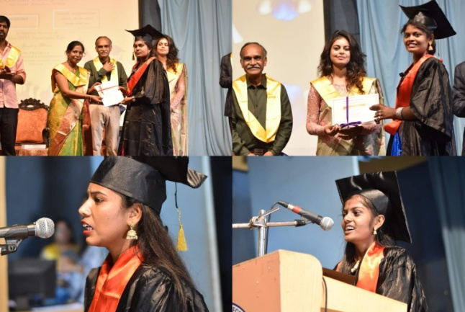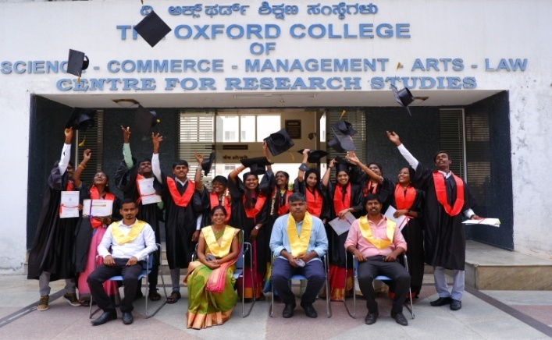

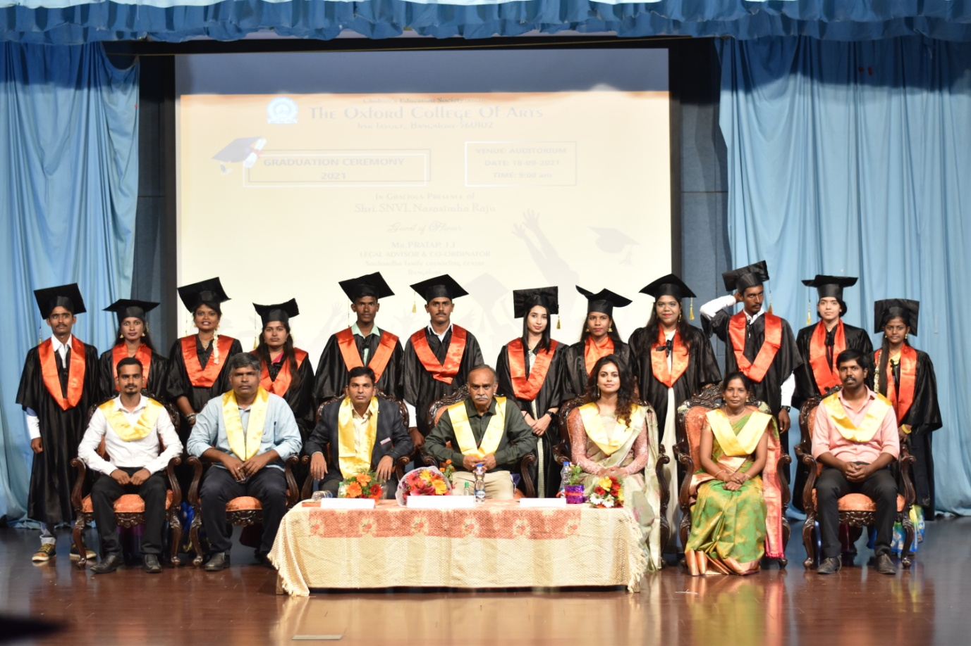

FAREWELL FOR THE BATCH 2019-2021

The 1st year students of the Department of Social Work have organised the Farewell Ceremony to the Out Going Batch of 2020-21 on 18th September 2021. The various activities were held to commemorate the ceremony and token of remembrance were offered to the outgoing batch.

